*Final Report* on

Text To Speech using FreeTTS

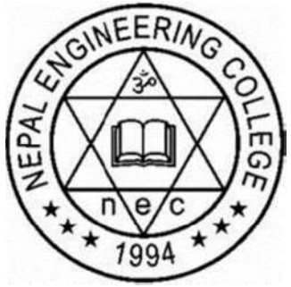

Submitted to

**Department of Computer Science and Engineering**

**Nepal Engineering College**

in Partial Fulfillment of the

Requirements for the Degree of B.E. in Computer

By

*Student Name1 (CRN)*

*Student Name2 (CRN)*

*Student Name3 (CRN)*

Supervised By: *Name_of_Supervisor*

Submission Date: *DD/MM/YYY*

# **ABSTRACT**

This project confer the tools and methodology used in developing a Nepali Text to Speech Synthesis System using FreeTTS and is written entirely in the Java programming language using FreeTTS synthesizer. Vocalized form of human communication is Speech. Here the Nepali Language is Synthetized based on formant approach and the use of most popular generic frameworks FreeTTS that is available in public domain for the development of a TTS synthesizer. The Text To Speech Architecture putting more emphasis on a components, namely Natural Language Processing (NLP) rather than Digital Signal Processing (DSP) component. Nepali language being mostly used language in Nepal and some parts of India and abroad, a text-to-speech (TTS) synthesizer for this language will prove to be a useful Information and communication technology (ICT) based system to aid to those majorities of people who are illiterate and also to those who are physical impairments like visually handicapped and vocally disabled physically handicapped. This ability to convert text to voice may reduce the dependency, frustration, and sense of helplessness of these people. The system can be extended to include more features such as more emotions, improved tokenization, interactive options and the use of minimal database.

**Keywords:** TTS, Prosody, Di-phone, Phoneme, Concatenation, Speech Synthesizer, Nepali vowel and consonants, Speech.

# **ACKNOWLEGDEMENT**

We would like to extend our gratitude towards Department of Computer Engineering, Nepal Engineering College and Pokhara University for providing a platform, opportunity to undertake an exclusive Major project.

We would like to thank all the members in Department of Computer Engineering and Project Coordinator along with all the teachers for providing help in the every step during the development of the project.

Furthermore, we would like to give special thanks to our Project Supervisor Mr. Krishna B. Shah for providing knowledge, support, help and encouragement in accomplishing the task that are needed for the development of our Major project.

Thank you, everyone.

Ashmita Ghimire (011-302)

Kiran Kumar Chaudhary (011-311)

***nec***

April, 2016

Contents

**ABSTRACT** i

**ACKNOWLEGDEMENT** ii

Introduction 1

# Introduction

FreeTTS is a speech synthesis system written entirely in the Java[1].

[1] “FreeTTS 1.2.3 - A speech synthesizer written entirely in the Java(TM) programming language.” [Online]. Available: https://freetts.sourceforge.io/#what_is_freetts. [Accessed: 18-Jun-2020].